ACADEMIC YEAR
2025-2025
EVEN SEM
NEWS LETTER
JAN 2026 – MAY 2026

ACADEMIC YEAR
2025-2025
EVEN SEM
NEWS LETTER
JAN 2026 – MAY 2026

ABSTRACT
FACULTY FDP’S
SL.NO | STAFF NAME | EVENT NAME | CONDUCTED BY | DURATION
1 | Mrs. M. SHUNMUGA SANKARI, HOD-EEE  Mr. T. KAMALKUMAR, AP-EEE | BLOCK CHAIN IN LOGISTICS | GRT INSTITUTE OF ENGINEERING AND TECHNOLOGY, TIRUTTANI | 26-01-2026
2 | Mrs. M. SHUNMUGA SANKARI, HOD-EEE  Mr. T. KAMALKUMAR, AP-EEE  Mr. S. GANESH, AP-EEE  Mrs. C. ANUSHA, AP-EEE | GENERATIVE AI FOR TEACHING | ECE DEPARTMENT T.J.S.ENGINEERING COLLEGE,  PERUVOYAL | 25-02-2026

DEPARTMENT ORGANISED FDP’S
SL.NO | EVENT COORDINATOR | EVENT NAME | RESOURCE PERSONS | DURATION
1 | Mrs. M. SHUNMUGA SANKARI, HOD-EEE  Mr. S. GANESH, AP-EEE | ELECTRICAL TECHNOLOGY-RECENT TRENDS AND INNOVATIONS | DR.J.PRAKASH, PRINCIPAL-TJSEC  DR.J.BALAMURUGAN, AEE-TANGEDCO  DR.AMOSEDINAKARAN, ASP-VEL TECH  DR.MOHAMED ABBAS S, HOD-PERI IOT  DR.P.SELVARAJ, PROF-DR.M.G.R ERI  DR.P.RAJA, PROF-NIT,TRICHY | 02-02-2026  to  07-02-2026

INDUSTRIAL VISITS
S.NO | STAFF COORDINATOR | ORGANISATION | PARTICIPATED STUDENTS | DATE
1 | Mr. S. GANESH, AP-EEE  Mrs. C. ANUSHA, AP-EEE | GLOBESCI TECHNOLOGY, KORATTUR | II & III STUDENTS | 13-02-2026
2 | Mr. S. GANESH, AP-EEE  Mrs. C. ANUSHA, AP-EEE | RETECH SOLUTIONS PRIVATE LIMITED, WEST TAMBARAM | II & III STUDENTS | 27-03-2026

STUDENT OTHER EVENTS
S.NO | NAME OF THE EVENT | VENUE | PARTICIPATED STUDENTS | DATE
1 | INSTITUTION’S INNOVATION COUNCIL | SEMINAR HALL | II & III STUDENTS | 13-02-2026
2 | INSTITUTION’S INNOVATION COUNCIL | SEMINAR HALL | II & III STUDENTS | 09-03-2026
3 | TECHUGHAM 2026 - PROJECT EXPO | VELTECH RANGARAJAN DR. SAGUNTHALA R&D INSTITUTE OF SCIENCE AND TECHNOLOGY | II & III STUDENTS | 04-03-2026
4 | 2ND INTERNATIONAL CONFERENCE (HYBRID MODE) | SKP ENGG COLLEGE  TIRUVANNAMALAI | IV STUDENTS | 04-03-2026
5 | XEMPLAR 2026 | VELAMMAL INSTITUTE OF  TECHNOLOGY,  PONNERI | III STUDENTS | 13-03-2026
6 | TECHNOVERSE HACKATHON 2K26 | ST.JOSEPH COLLEGE OF ENGINEERING & TECHNOLOGY,CHENNAI | III STUDENTS | 14-03-2026
7 | INTERNATIONAL CONFERENCE | ST.PETER’S INSTITUTE OF HIGHER EDUCATION AND RESEARCH, CHENNAI | III STUDENTS | 13-03-2026
8 | IDEATHON | ST.PETER’S ENGINEERING COLLEGE,CHENNAI | III STUDENTS | 17-03-2026
9 | NATIONAL CONFERENCE | PRATHYUSHA ENGGINEERING COLLEGE | III STUDENTS | 25-04-2026

S.NO | PRESENTED BY | ATTENDED BY | DATE
1 | Ms. NANDHINI  FIIT FORMACION PVT LTD | II & III STUDENTS | 28-01-2026
2 | Mr. V. SUJEETH VISHNU (ONLINE)  OPC PVT LTD | II & III STUDENTS | 21-02-2026
GUEST LECTURE

INTERNSHIP
S.NO | NAME OF THE ORGANISATION | ATTENDED BY | DATE
1 | MITSUBA INDIA PVT LTD | II & III STUDENTS | 02-03-2026  To  31-03-2026

ALUMNI INTERACTION
S.NO | NAME OF THE ALUMNI | ATTENDED BY | DATE
1 | UDHAYAKUMARAN B (112821105009) | II STUDENTS | 02-02-2026

26-01-2026
FACULTY DEVELOPMENT PROGRAM
GRT INSTITUTE OF ENGINEERING AND TECHNOLOGY, TIRUTTANI conducted Faculty Development Program on “BLOCK CHAIN IN LOGISTICS” the following faculties are attended the event

Mrs. M. Shunmuga sankari, HOD-EEE
Mr. T. Kamalkumar, AP-EEE
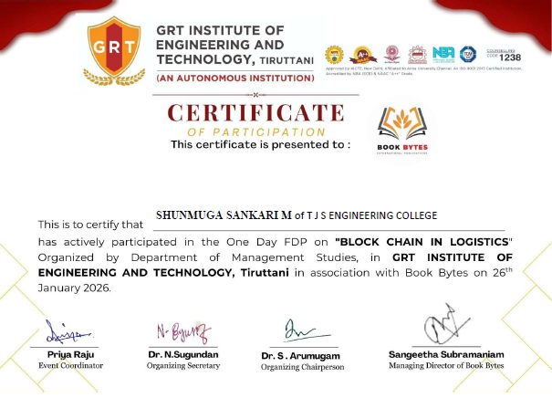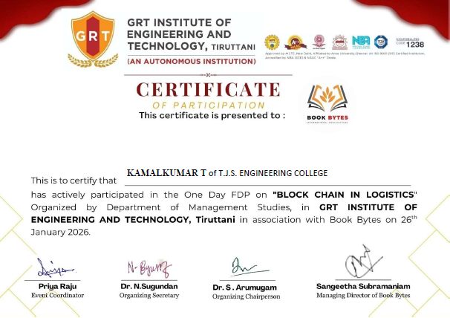

28-01-2026
GUEST LECTURE
The Department of Electrical and Electronics Engineering in association with FIIT Formacion Pvt Ltd, successfully organised a GUEST LECTURE on “IOT – FUNDAMENTALS AND APPLICATIONS”. The session was handled by Ms. Nandhini, Resource person from FIIT Formacion Pvt Ltd on 28 JANUARY 2026 from 2.00PM to 3.00PM at the EEE Seminar Hall.
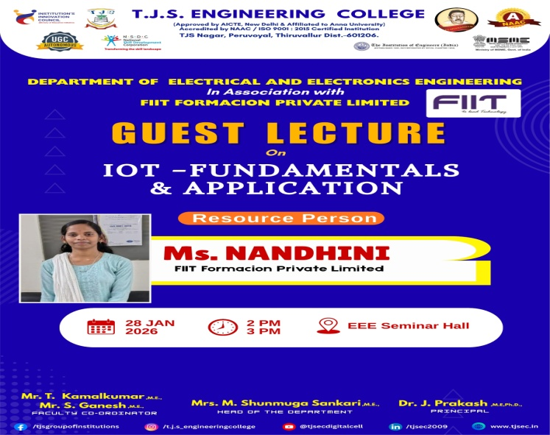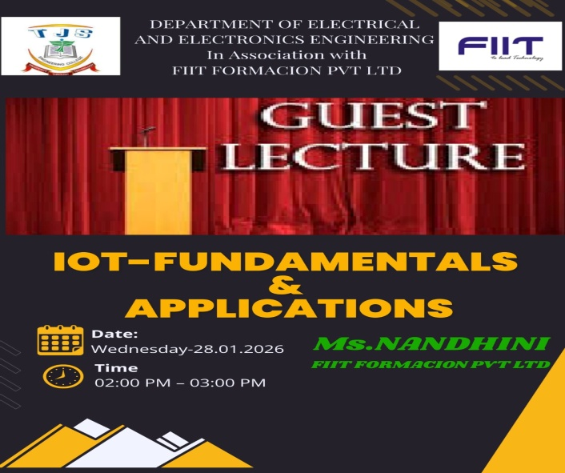
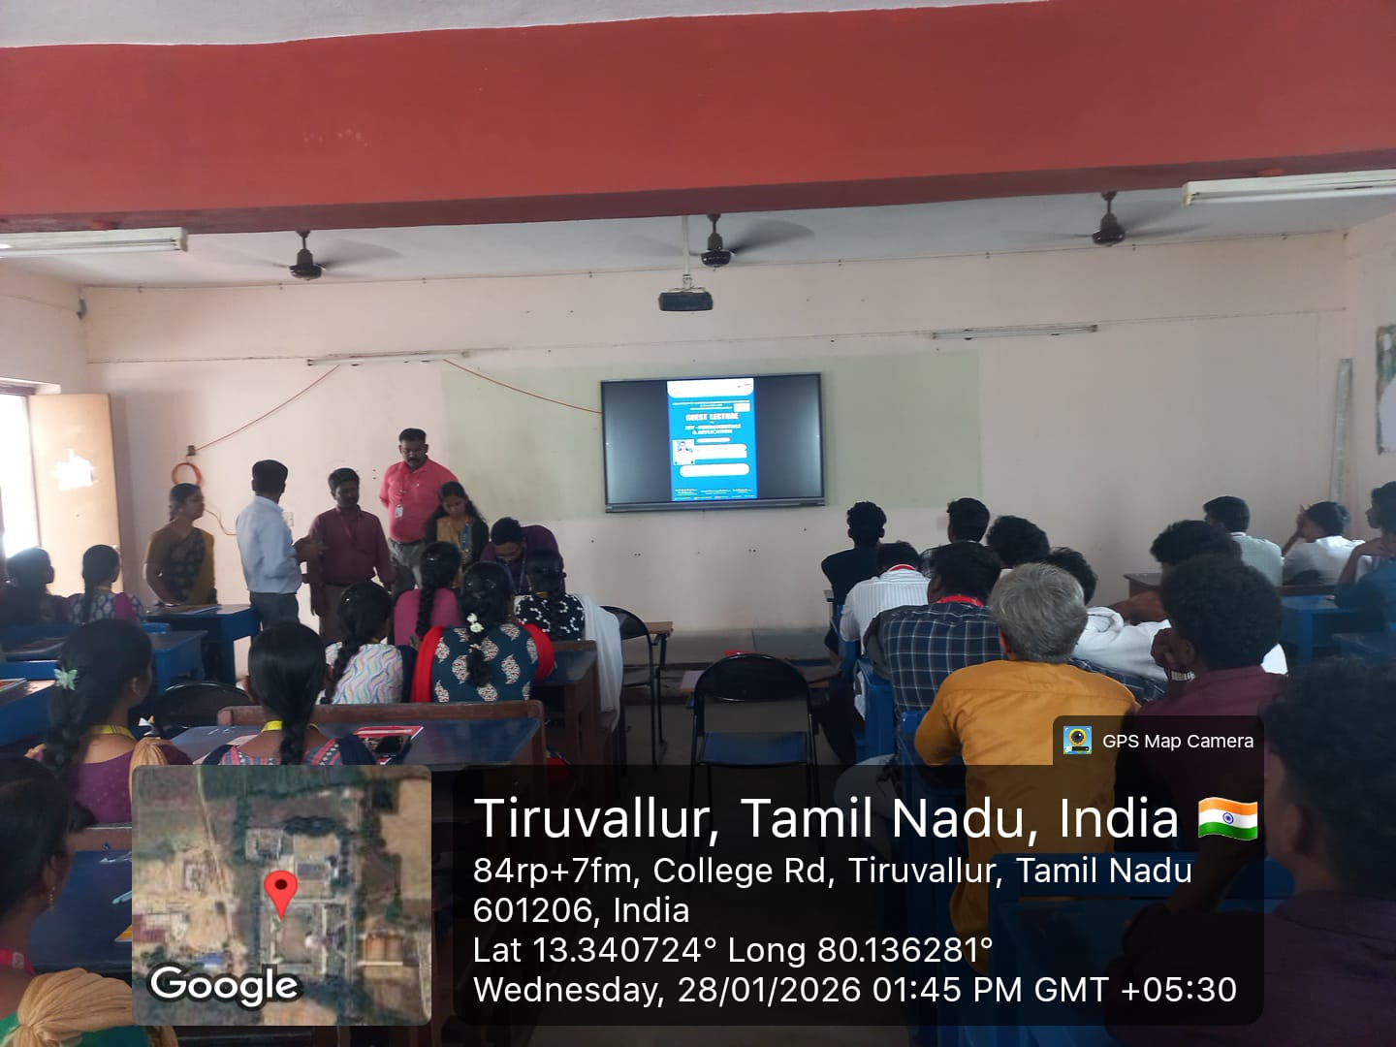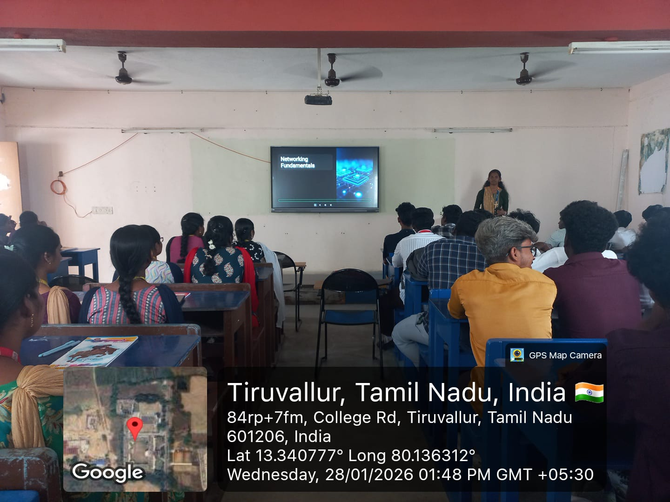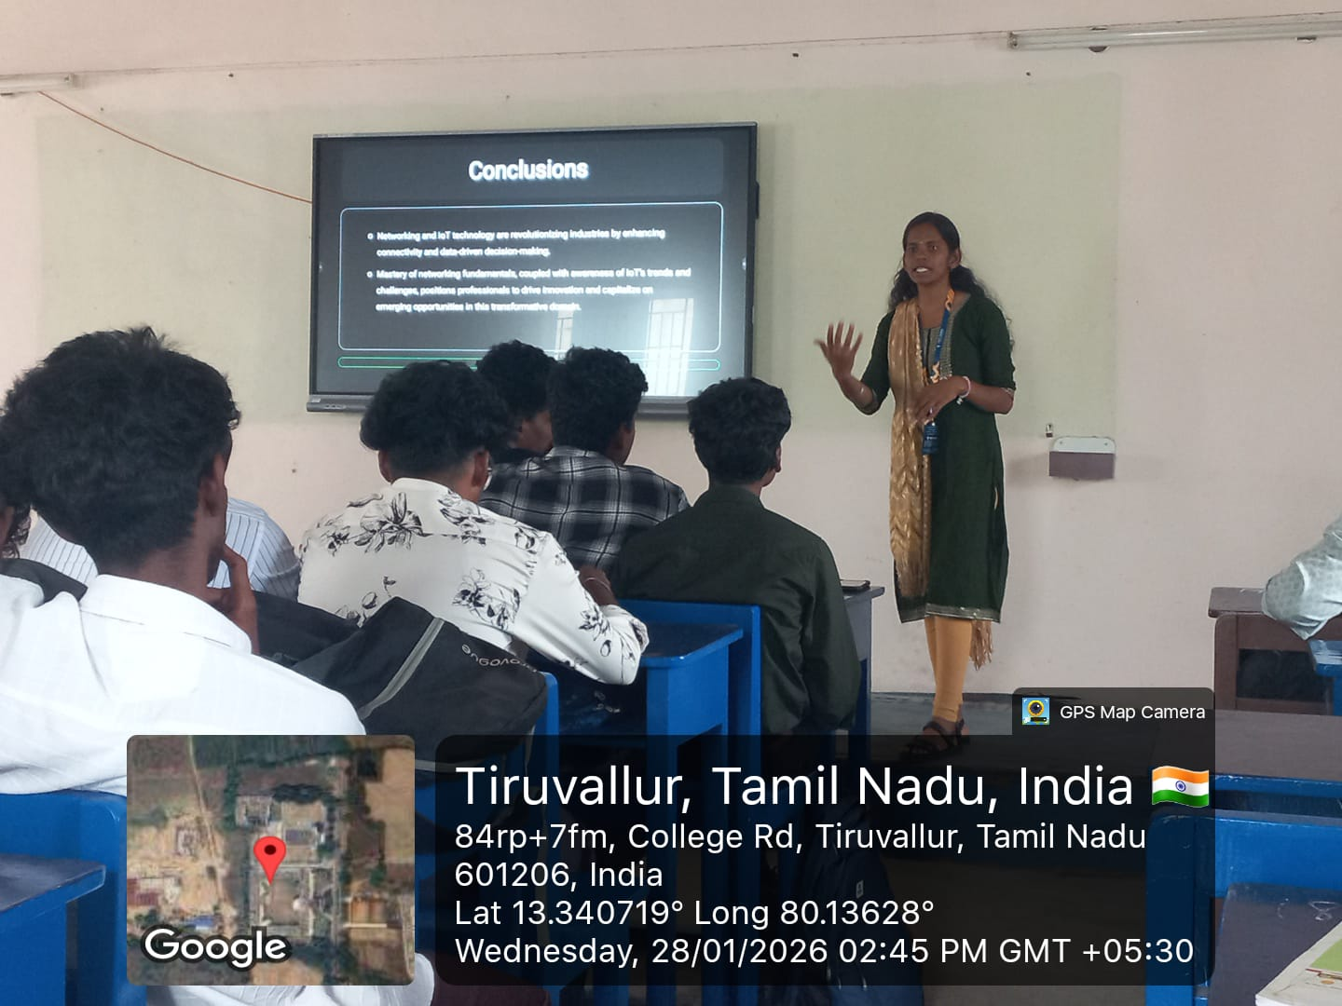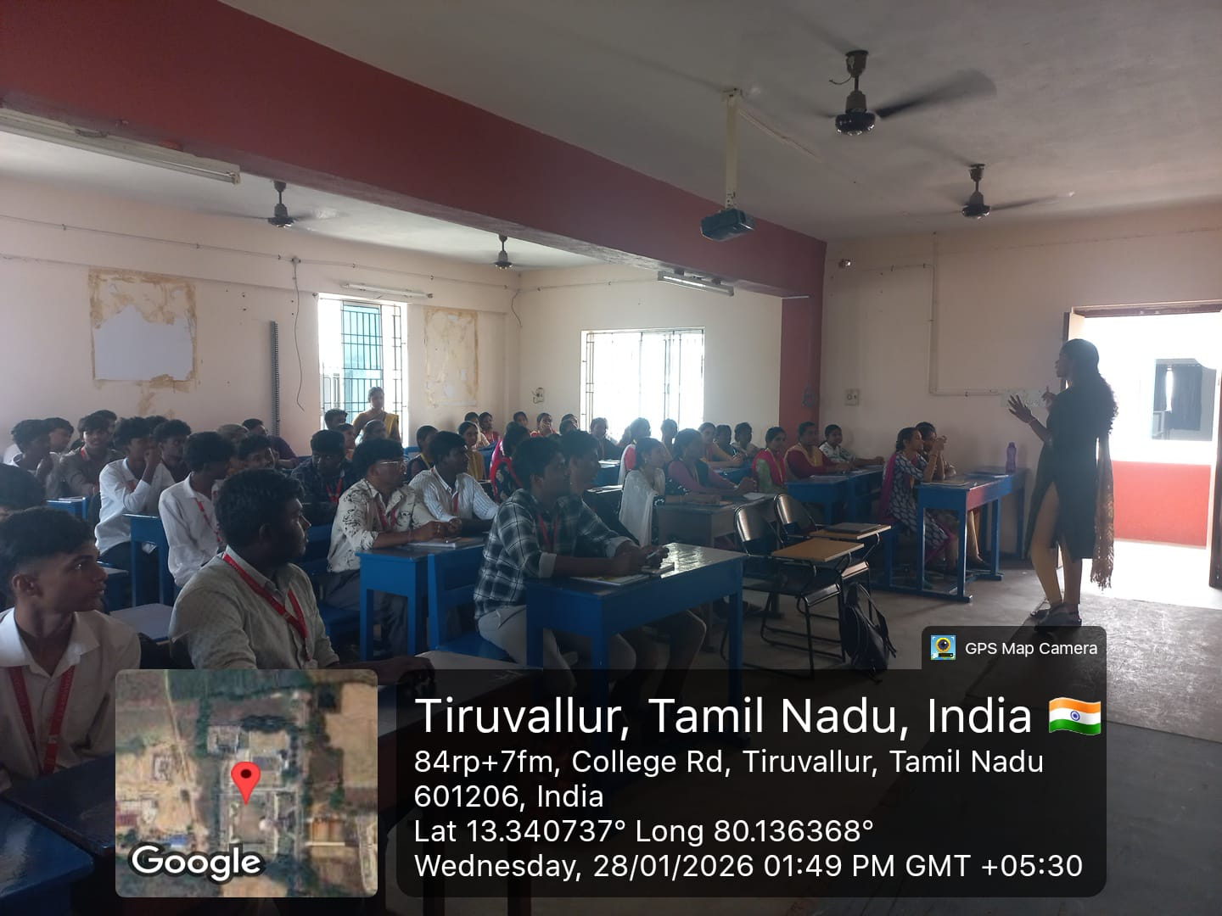

29-01-2026
IIC MEETING
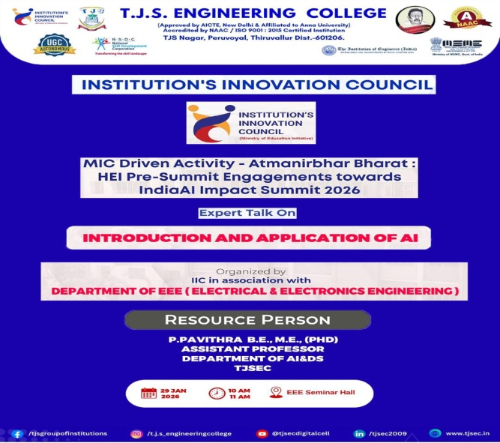
Ms. P. Pavithra, AP-AIDS TJSEC has conducted an “INSTITUTION’S INNOVATION COUNCIL” meeting for the II & III year students of EEE in the title of “INTRODUCTION AND APPLICATION OF AI”

02-02-2026
ALUMNI INTERACTION
Mr. B. Udhayakumaran (112821105009 - 2025 BATCH) ALUMNI student has been interacted with our II year students.
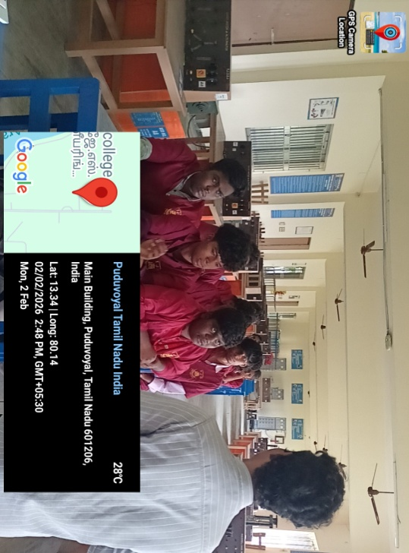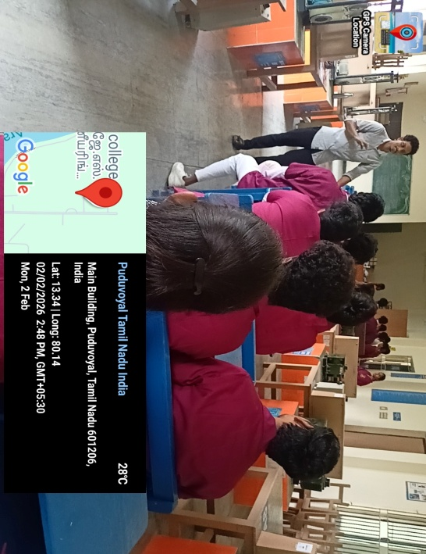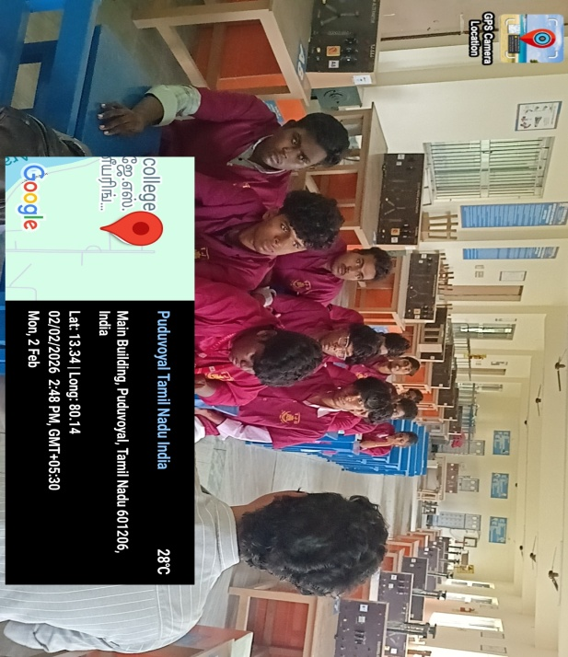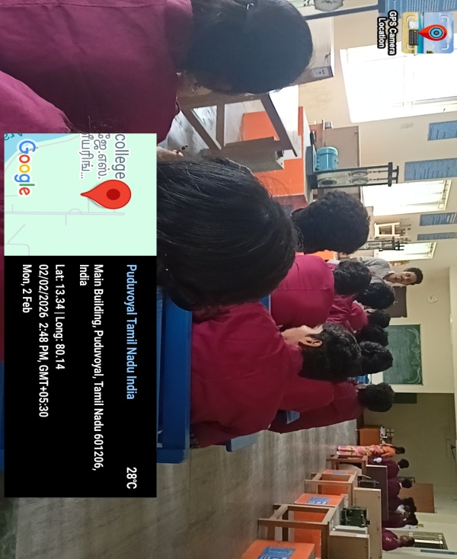

02-02-2026 TO 07-02-2026
6 DAYS FACULTY DEVELOPMENT PROGRAM (ONLINE)
DR.J.PRAKASH, PRINCIPAL-TJSEC has conducted a FDP (Online) on the title of “ADVANCED TECHNIQUES IN SOLAR PHOTOVOLTAIC SYSTEMS”

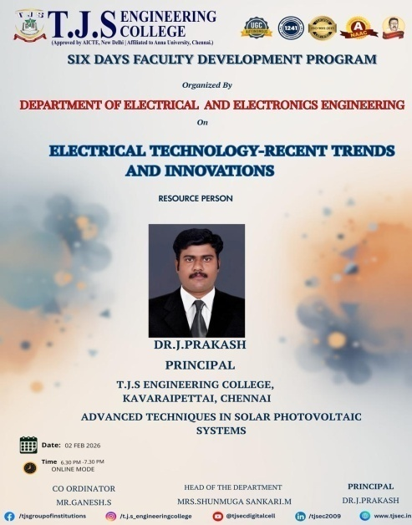

DR.J.BALAMURUGAN, ASSISTANT EXECUTIVE ENGINEER –TANGEDCO has conducted a FDP (Online) on 03-02-2026 in the title of “POWER TO THE PEOPLE – SMART GRID – YOUR OWN ELECTRICITY MARKET”

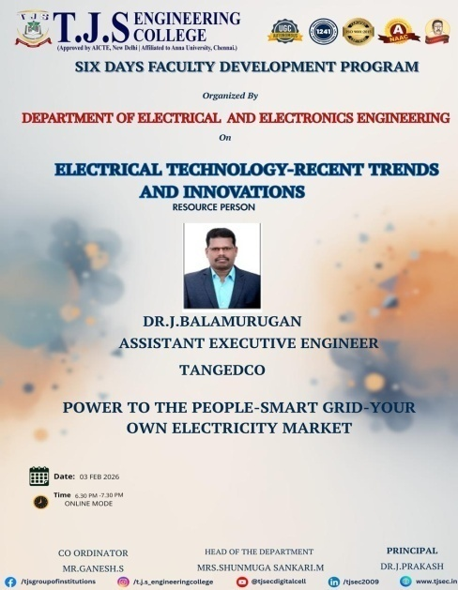

DR.AMOSEDINAKARAN, ASP-Vel Tech Rangarajan Dr. Sagunthala R&D Institute of Science and Technology has conducted a FDP (Online) on 04-02-2026 in the title of “INTROCUCTION TO ANSYS MAXWELL AND OPTIMAL DESIGN OF A SQUIRREL-CAGE INDUCTION MOTOR”

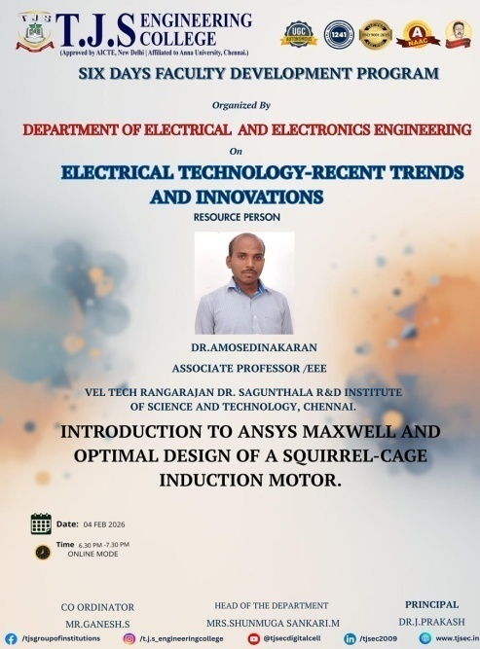

DR.MOHAMED ABBAS S, HOD-PERI Institute of Technology has conducted a FDP (Online) on 05-02-2026 in the title of “INTERNET OF THINGS AND ITS APPLICATIONS”

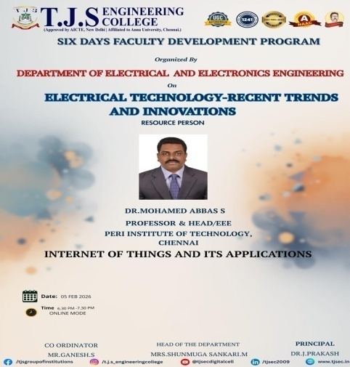

DR.P.SELVARAJ, PROF-DR.M.G.R Educational and Research Institute, Chennai has conducted a FDP (Online) on 06-02-2026 in the title of “RENEWABLE ENERGY, SMART GRIDS, ENERGY STORAGE AND VEHICLE-TO-GRID INTEGRATION: ADVANCEMENTS, APPLICATIONS, KEY PLAYERS AND CHELLENGES”.

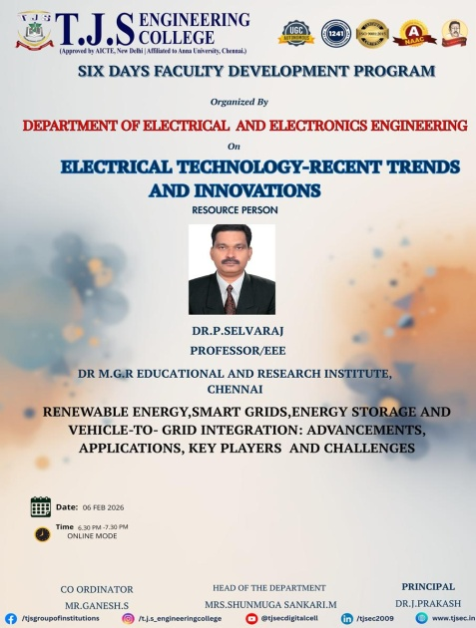

DR.P.RAJA, PROF-National Institute of Technology, TRICHY has conducted a FDP (Online) on 07-02-2026 in the title of “AN OVERVIEW ON DC MICRO GRID AND PROTECTION”
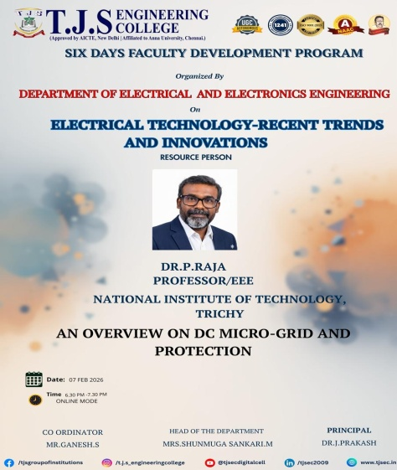

13-02-2026
INDUSTRIAL VISIT
The II & III Year students visited “GLOBESCI TECHNOLOGY KORATTUR” for the industrial visit for their career growth and future scope.
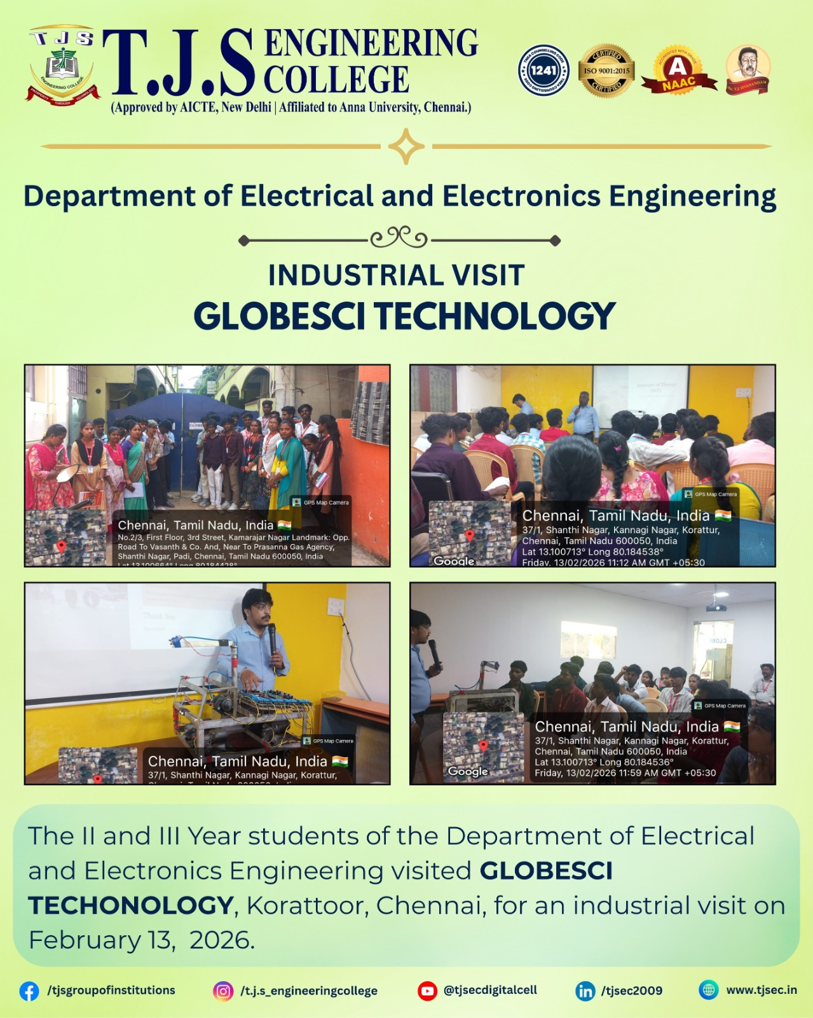
21-02-2026
GUEST LECTURE
Mr. Sujeeth Vishnu-Chief Business Development Executive from OPC Pvt Ltd has conducted a Career Guidance Program in the title of “WHY ENGINEERING IS THE BEST CHOICE FOR DIPLOMA STUDENTS” for the II & III Year students with the coordination of Mrs. M. Shunmuga sankari, HOD-EEE and Mr. T. Kamalkumar, AP-EEE

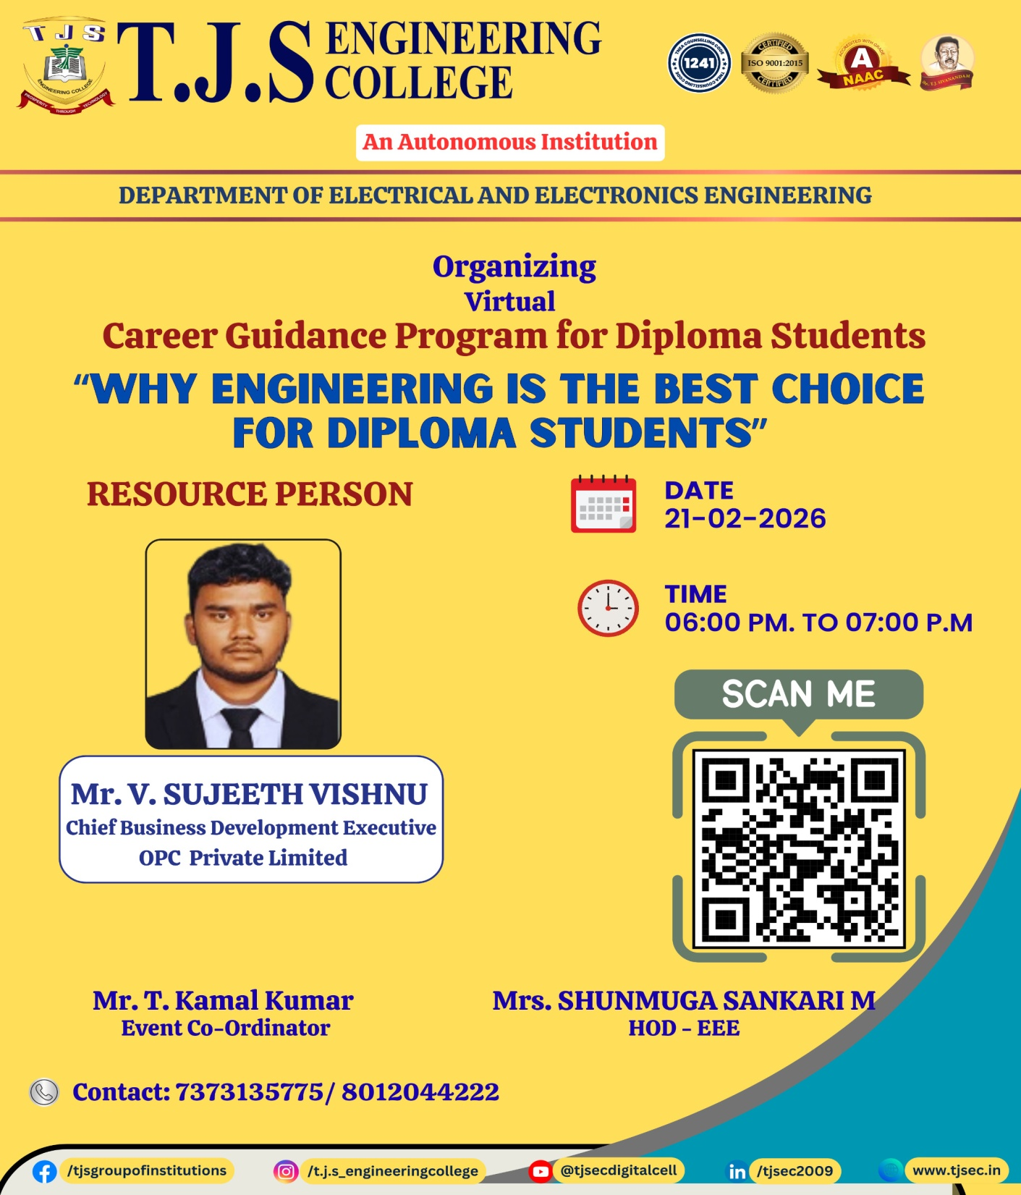

25-02-2026
FACULTY DEVELOPMENT PROGRAM
From ECE Department T.J.S. Engineering College, Peruvoyal conducted One Faculty Development Program on “Generative AI for Teaching” the following faculties are attended the event

Mrs. M. Shunmuga sankari, HOD-EEE
Mr. T. Kamalkumar, AP-EEE
Mr. S. Ganesh, AP-EEE
Mrs. C. Anusha, AP-EEE
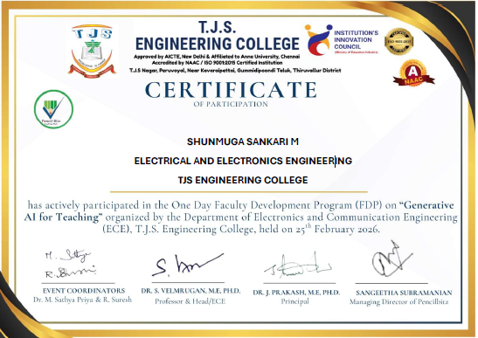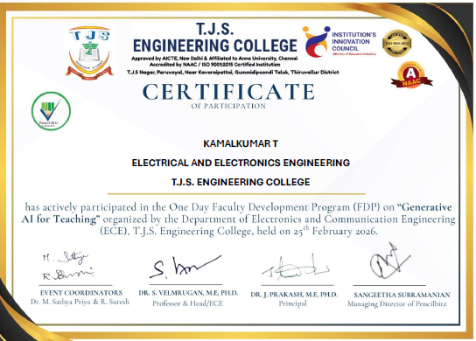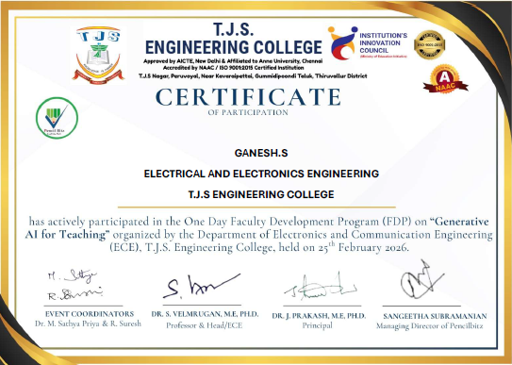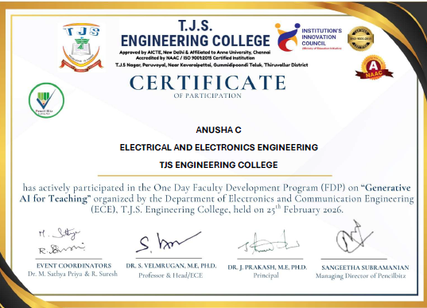

02-02-2026
INTERNSHIP
From II & III year 6 students went for internship at Mitsuba India Pvt. Ltd, Gummidipoondi
S.No | Year | Register No | Name of the Student
1 | III | 112823105002 | ARAVIND T
2 | III | 112823105007 | DIWAKAR S
3 | III | 112823105009 | HARINIYA S
4 | III | 112823105015 | LINGESHWARAN N
5 | III | 112823105018 | VIJAYAKUMAR V
6 | II | 112824105301 | ANANDH R

04-03-2026
PROJECT EXPO
Our II & III Year Students participated in “TECHUYUGAM 2026” at Veltech Multitech Engineering College, Avadi. They won the cash price and rewards.
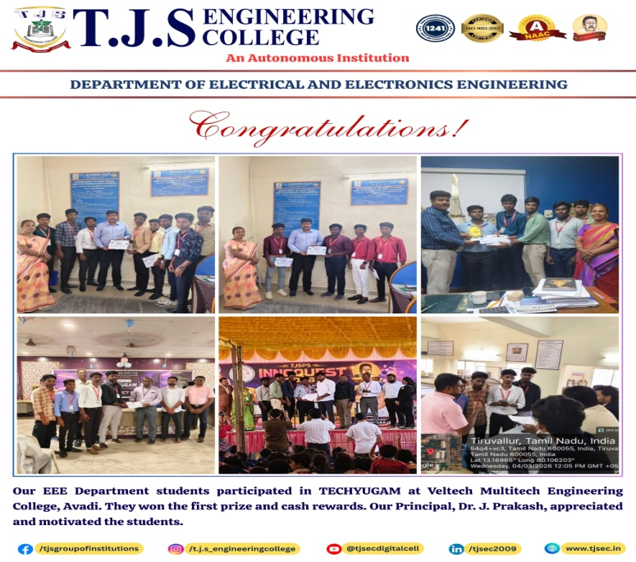
09-03-2026
IIC MEETING
Our II & III Year students attended online MIC DRIVEN ACTIVITY – Sabka Sath Sabka Vikas
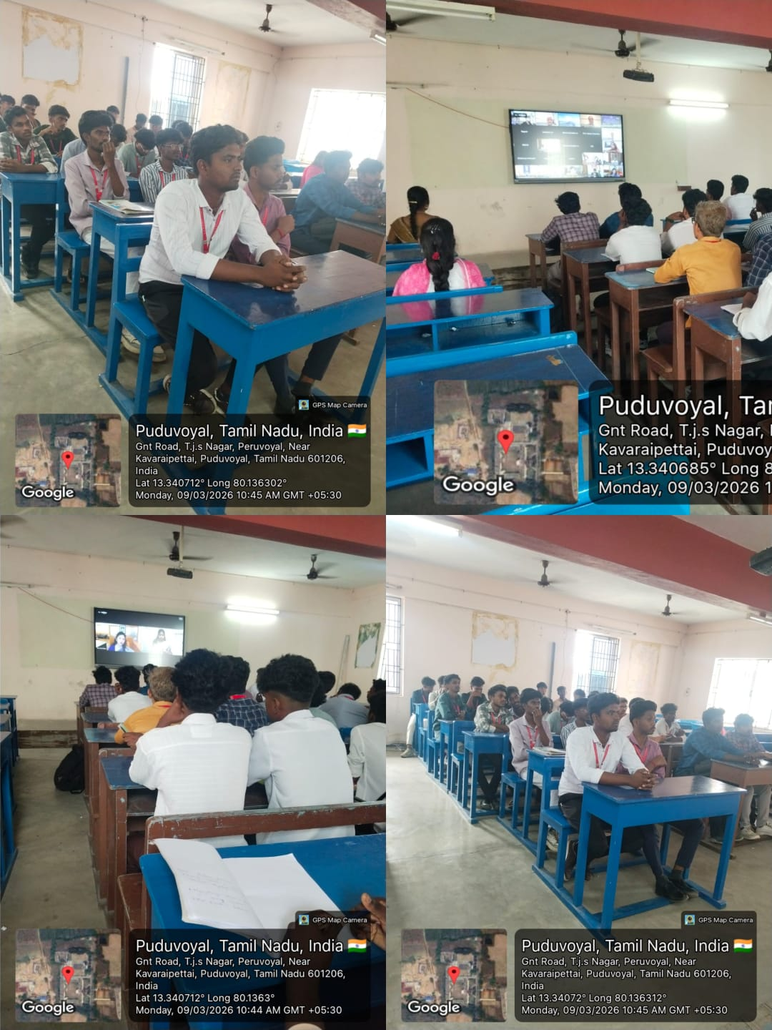
13-03-2026
INTERNATIONAL CONFERENCE
Our IV Year students attended International Conference in Online mode at SKP ENGINEERING COLLEGE,Thiruvannamalai.

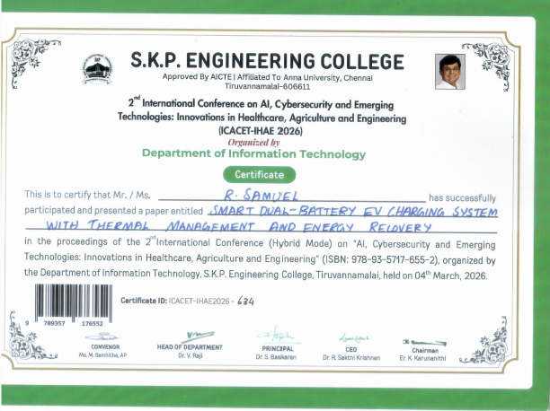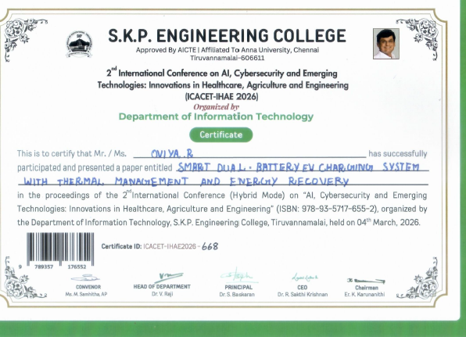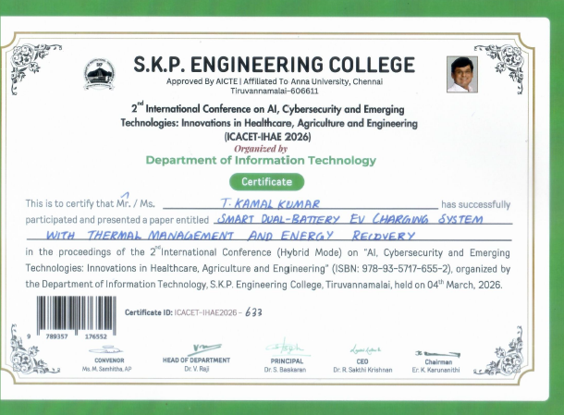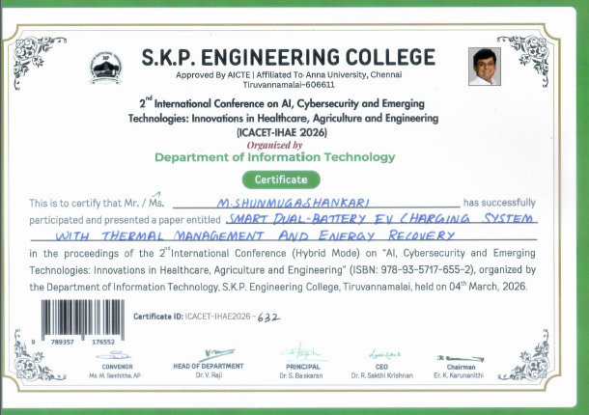
13-03-2026
Our II & III Year students attended the XEMPLER 2026 Symposium from “Vellammal Engineering College”
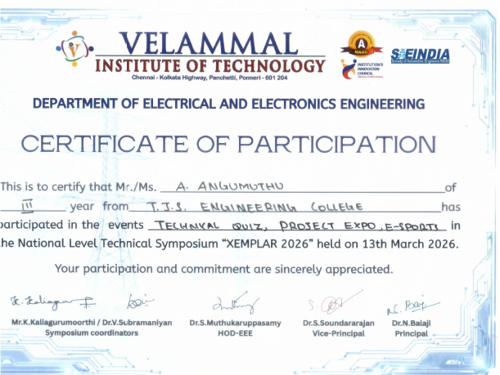

14-03-2026
TECHNOVERSE HACKATHON 2026
Our III year students participated on the “TECHNOVERSE HACKATHON 2026” at St.Joseph’s College of Engineering & Technology.
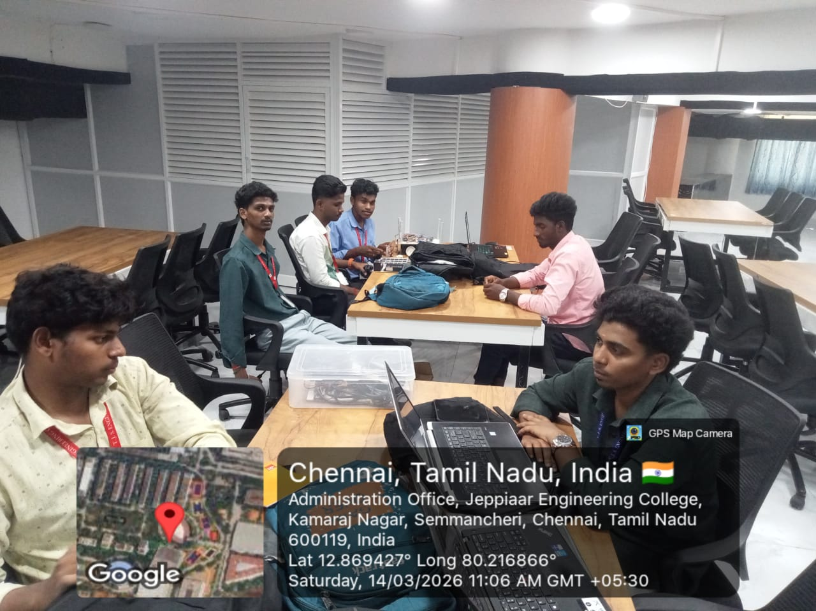

18-03-2026
IDEATHON
Our III Year students went to “IDEATHON” on St.Peter’s Engineering College
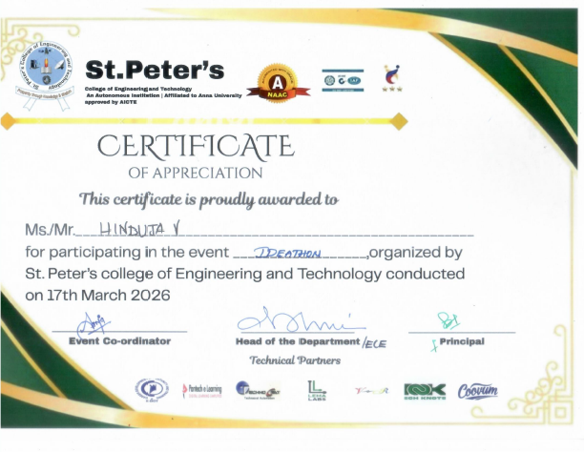

25-03-2026
NATIONAL CONFERENCE
Our III Year students went for NATIONAL CONFERENCE for the paper presentation on the title of “SOLAR INTEGRATED POWER MANAGEMENT SYSTEM FOR ELECTRIC TWO WHEELER” at Prathyusha Engineering College.
